CS 255 System Design Document C.Frediani

UML Diagrams

UML Use Case Diagram

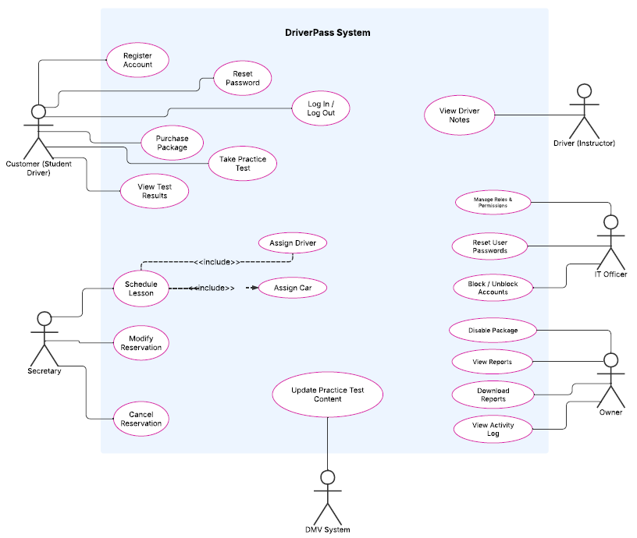

UML Activity Diagrams

UC1: Schedule Driving Lesson UC2: Take Online Practice Test
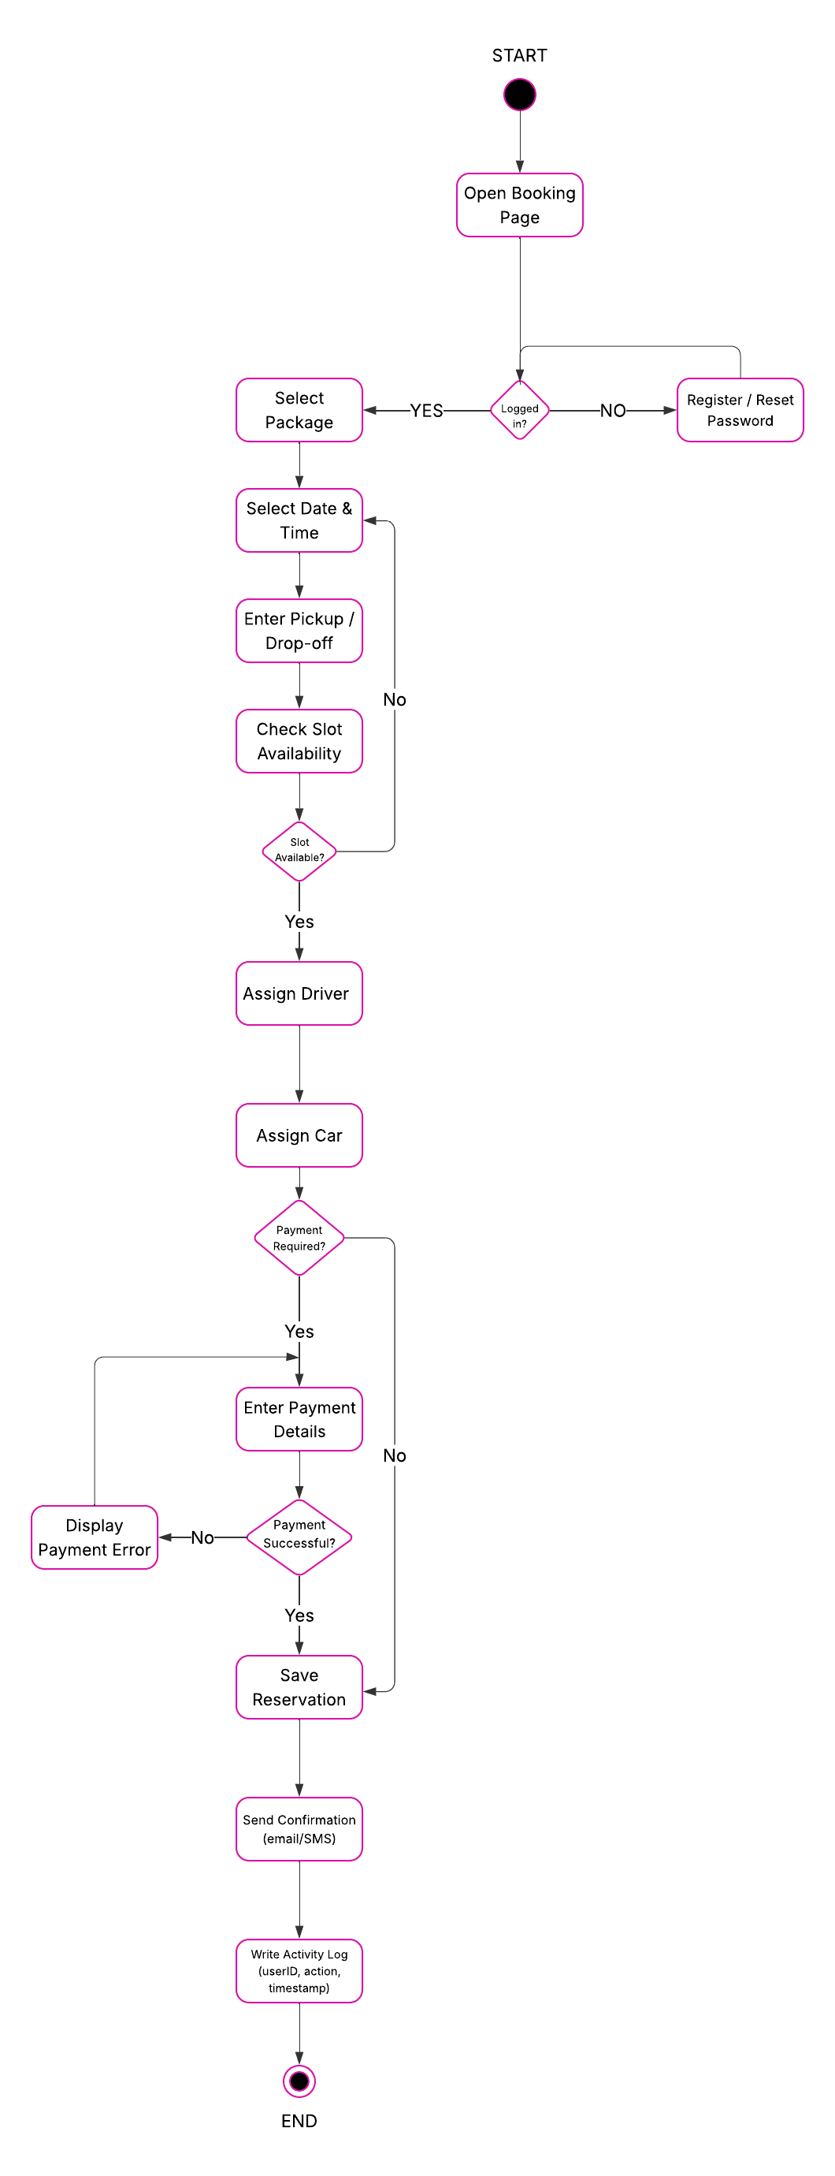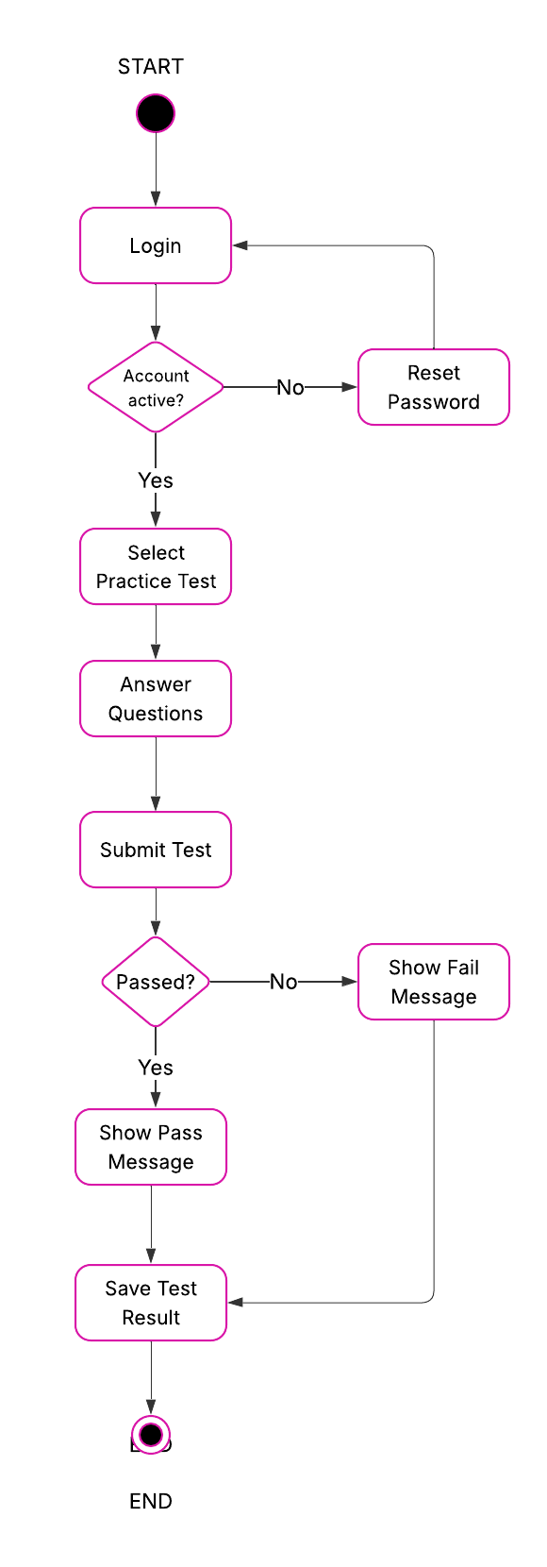

UML Sequence Diagram

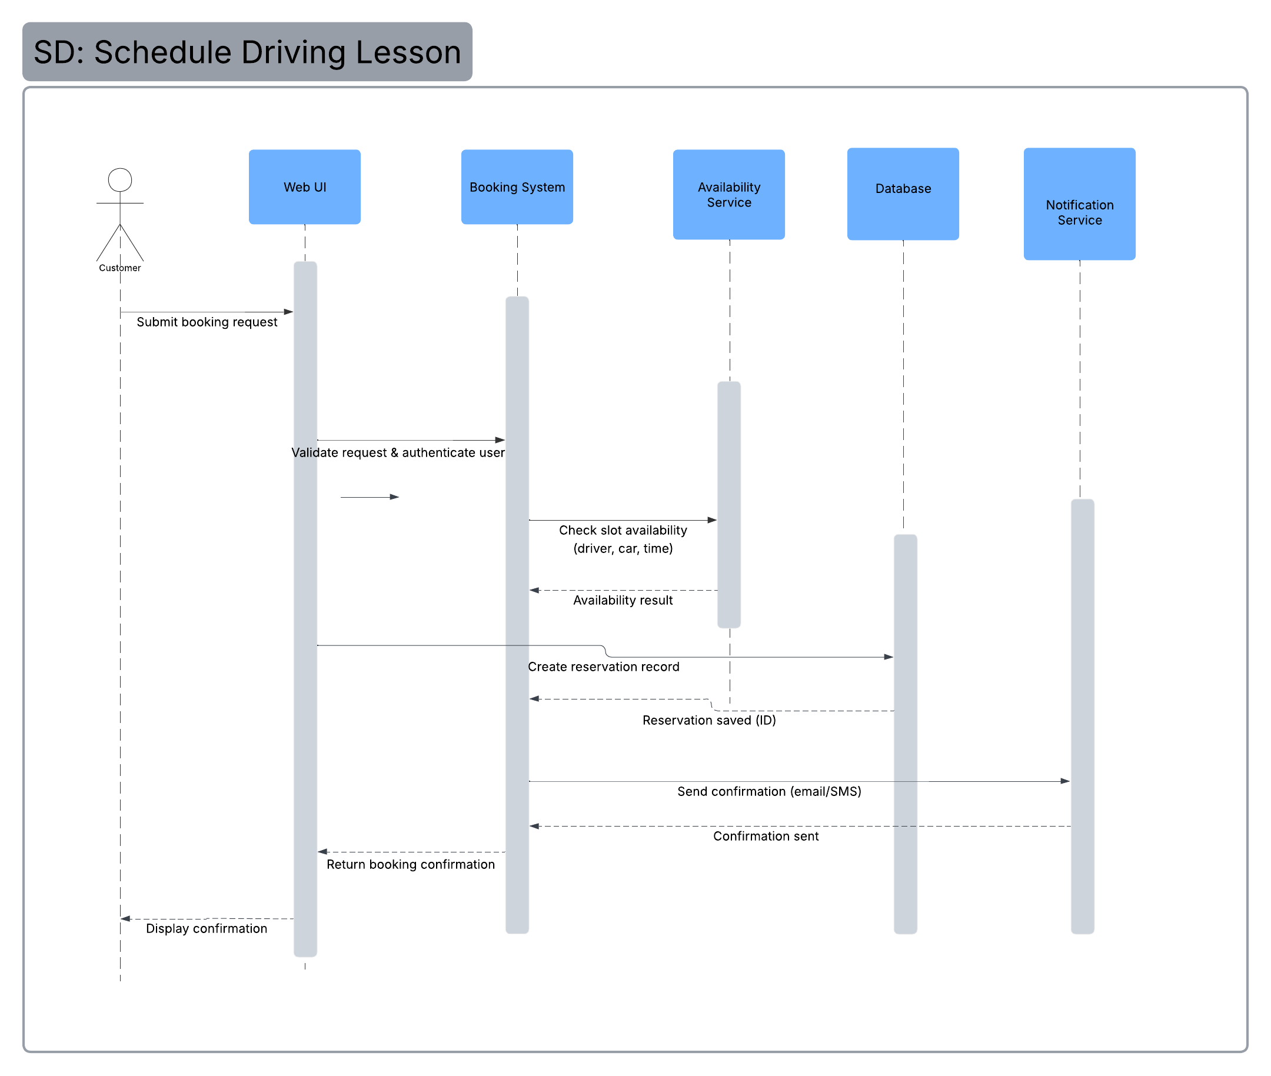

UML Class Diagram

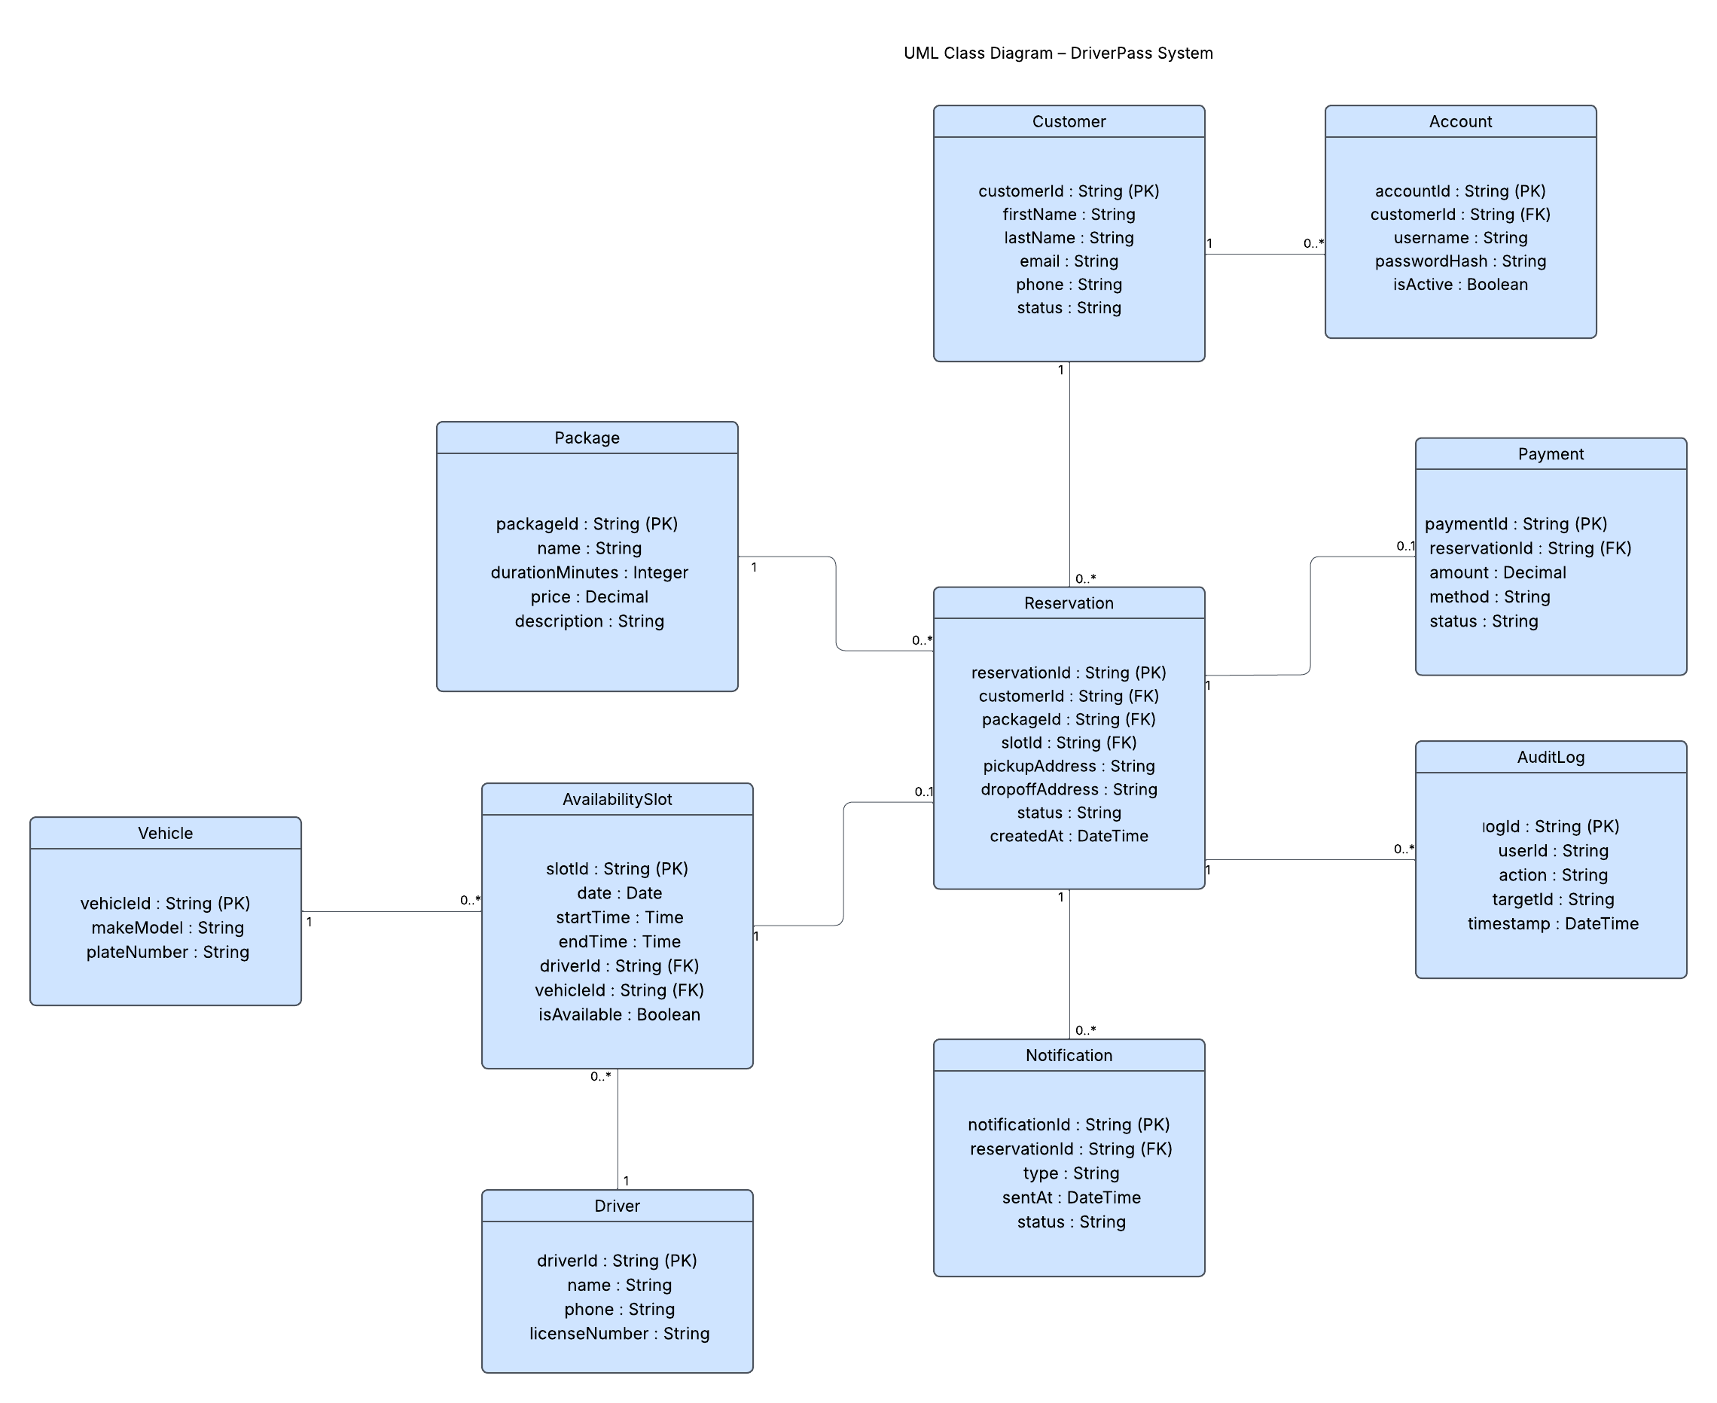

Technical Requirements

The DriverPass system is designed as a secure, cloud-based web application that supports online lesson scheduling, practice testing, payment processing, and administrative management. The following technical requirements outline the hardware, software, tools, and infrastructure necessary to support the system design.

Hardware Requirements
The DriverPass system will operate within a cloud-hosted environment, eliminating the need for on-site physical servers. The required hardware components include:
- Cloud-hosted virtual servers to run the web application and backend services
- A managed relational database server hosted in the cloud
- Office desktop computers or laptops for administrative users (owner, secretary, IT administrator)
- Customer devices such as smartphones, tablets, or personal computers
- Reliable broadband internet connectivity for all users
Because the system is web-based, end users only require a modern device capable of accessing a secure web browser. The cloud hosting provider will supply the physical infrastructure, including processing power, storage, and redundancy.

Software Requirements
The DriverPass system requires a multi-tier software architecture consisting of the following components:
- A web application framework (such as .NET, Java, or Node.js) to manage business logic
- A relational database management system (such as MySQL or PostgreSQL) to store customer, reservation, payment, and availability data
- A secure web browser for user interaction
- Secure authentication services to manage login credentials and role-based access control
- Payment gateway integration (PCI-compliant) for secure credit card processing
- Email and/or SMS notification services to send booking confirmations and updates
- Secure communication protocols (HTTPS using SSL/TLS encryption)
The system must support user authentication, password hashing, session management, and encrypted transmission of sensitive data. All customer information and payment data must be securely stored and processed in accordance with industry standards.

Development and Support Tools
To develop, test, and maintain the DriverPass system, the following tools are required:
- Lucidchart for UML modeling and system documentation
- An Integrated Development Environment (IDE) such as Visual Studio or IntelliJ
- Version control software (e.g., Git) to manage code revisions
- Testing tools to perform functional, integration, and user acceptance testing
- Monitoring and logging tools to track system performance and security events
- Automated backup tools provided by the cloud hosting provider
These tools ensure that the system can be developed efficiently, tested thoroughly, and maintained securely over time.

Infrastructure Requirements
The DriverPass system will utilize a cloud-based infrastructure to ensure scalability, reliability, and availability. The infrastructure must support:
- High availability and redundancy to prevent service interruptions
- Automated daily database backups
- Role-based access control (RBAC) to restrict user permissions
- Activity logging to track reservation creation, modification, and cancellation
- Secure API integration to allow future updates from the DMV
- Scalable resources to handle increased customer demand
The infrastructure must support concurrent users accessing the system simultaneously without performance degradation. The system should also allow administrators to access reports remotely while maintaining strict security controls.

Security Requirements
Because the DriverPass system manages personal information and payment data, security is a critical requirement. The system must include:
- Encrypted data transmission using HTTPS
- Secure password hashing and authentication mechanisms
- Role-based access permissions for administrative staff
- Secure payment processing through a PCI-compliant gateway
- Audit logging for all reservation and account changes
- Automatic password reset functionality
- Account lockout after repeated failed login attempts
These measures ensure that customer information is protected and that administrative actions can be tracked for accountability.

